
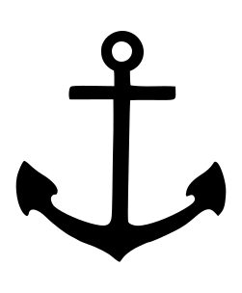
2026 Findley Lake Fun Map

Company Name:

Email:

Spots Needed (1.5 x 2”) $150 Per Spot

Ok To Use 2025 Spot? YES ____ NO____

Need Spot Produced? YES____ NO____
If So Please Send Info to Dan@ourowncandlecompany.com

Event to Promote:

Payment can be via check mailed to POB 82 Findley Lake NY 14736
Credit card payment can be handled through visitfindleylake.com website…follow the prompts

SPOTS, EVENT INFO, AND PAYMENT DUE BY 12/10
TO BE IN 2026 FUN MAP

